
Kootenay Lake – Student Handbook
Updated September 2025



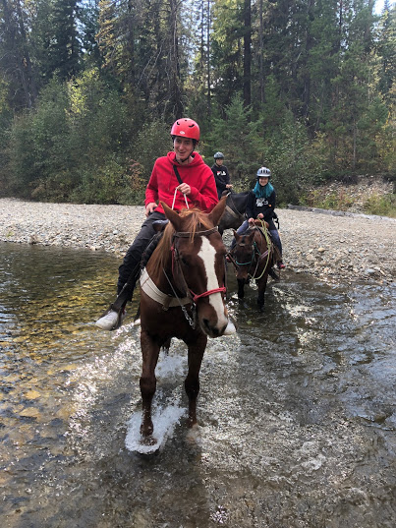
CONTENTS

MISSION
CONTACT
MEETINGS
HOMESTAY
LIFESTYLE
CURRICULUM
EXTRA CURRUCULUM
TRAVEL
MEDICAL
CULTURE SHOCK
CONDUCT
SUMMARY

MISSION

Our mission is to inspire and support each learner to thrive in a caring learning environment.

CONTACT
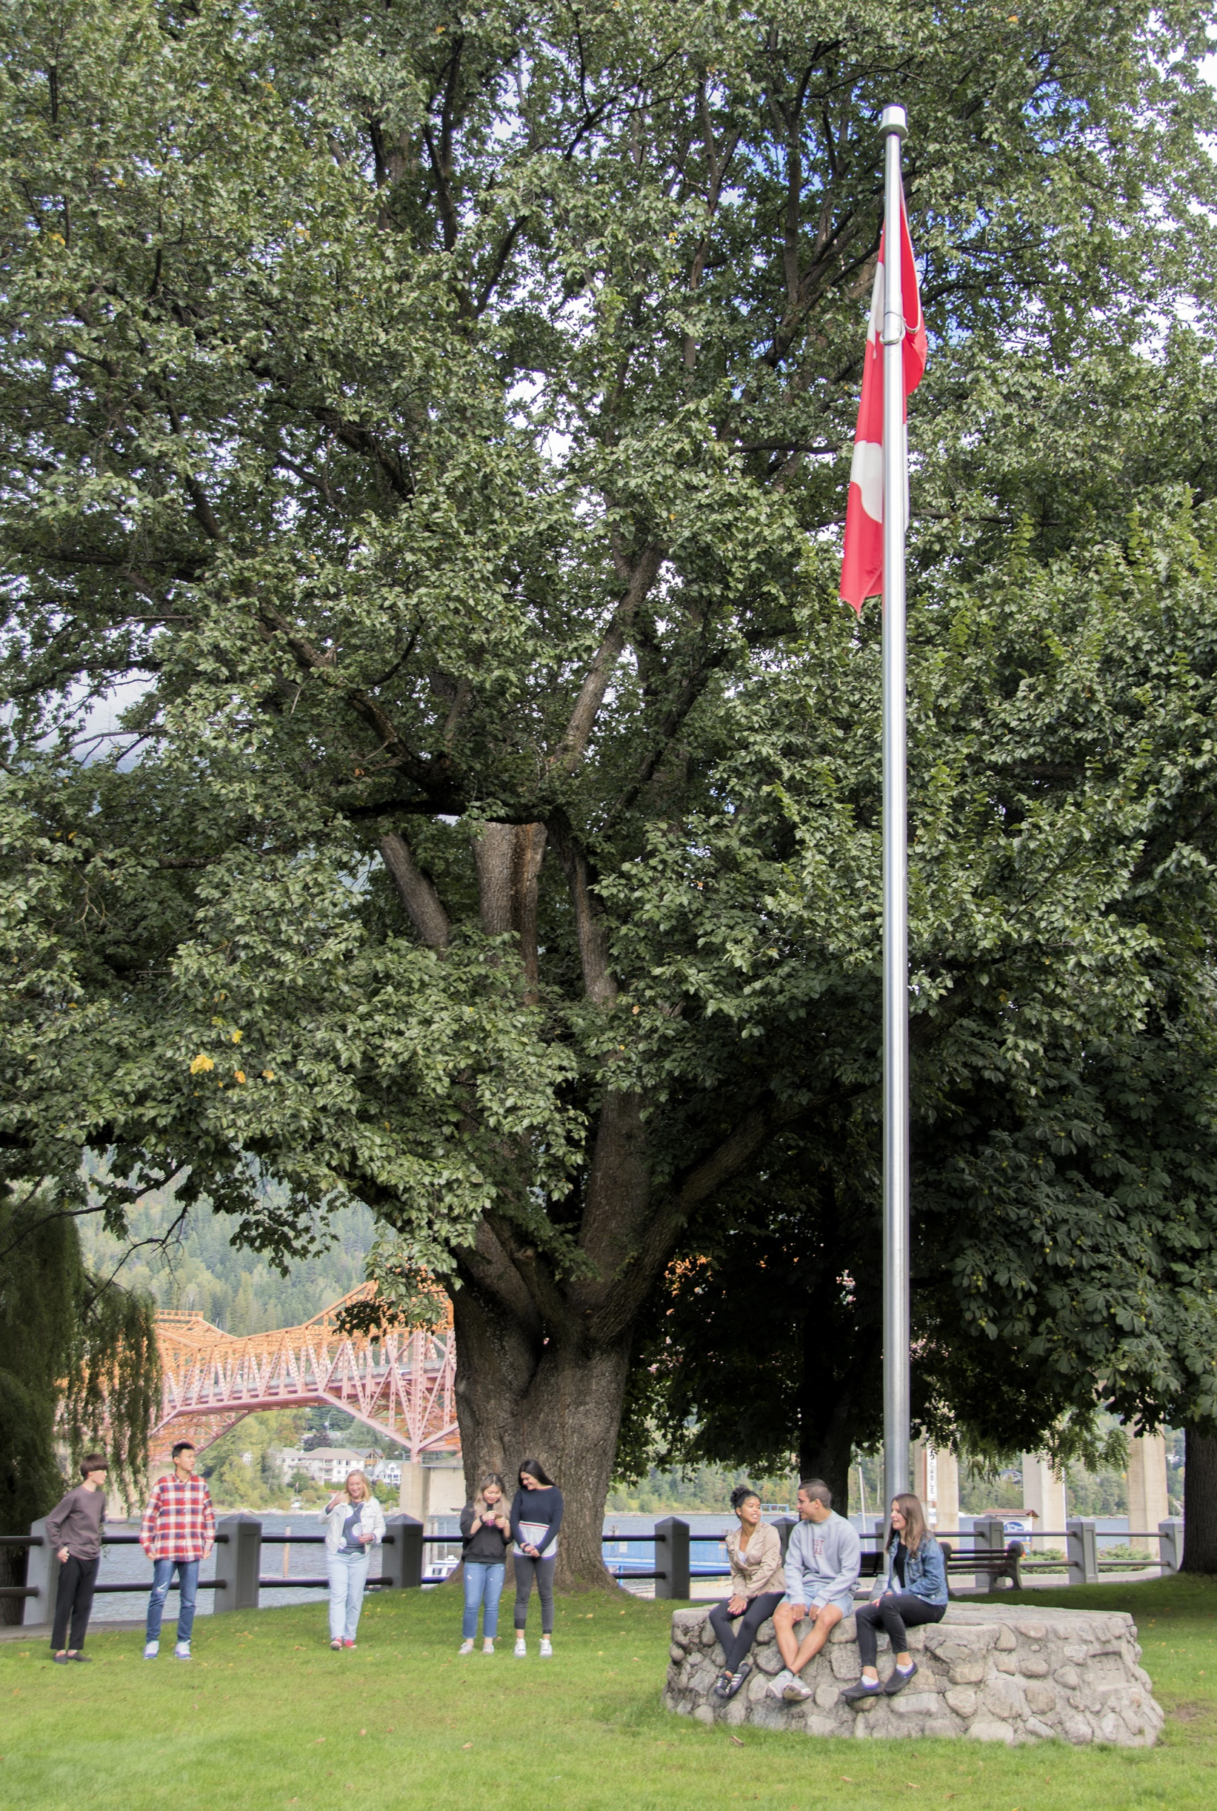
Mail Address
- 811 Stanley St., 3rd Floor, Nelson, BC., V1L 1N8
Physical Address
- LVR school lower building (room 012)
Phone
- 250-505-7015
District Principal
- Kent Tamblyn kent.tamblyn@sd8.bc.ca 1 250-354-3712
Program Coordinator
- Shannon Ellis international.coordinator@sd8.bc.ca 1 250-505-7015
Homestay Contractor (KRS, SSS, JVH)
- Norman Eady kootenay.homestayeast@sd8.bc.ca 1 867-332-7444
Homestay Contractor (LVR, MSS)
- Kathy Stowell kootenay.homestaywest@sd8.bc.ca 1 250-551-7409

Communication Flow





Example | Urgency | Position | Contact
 |  | 
Medical Emergency | Immediate | International Principal | 250-354-3712 Email
Illegal Activity | Immediate | International Principal | 250-354-3712 Email
Medical non-emergency | Business hours 9:00-5:00 | Homestay Contractor | TBD
Problem Solving | Business hours 9:00-5:00 | Homestay Contractor | TBD
Academic & attendance | Business hours 9:00-5:00 | Program Coordinator | 250-505-7015 Email
Program Inquiries | Business hours 9:00-5:00 | Program Coordinator | 250-505-7015 Email

Medical Emergency
- Attend hospital
- Contact International Principal (International Principal contacts agent and natural parents)
- Contact Assistance Team at 1-866-883-9787 studentassist@studyinsured.com (available 24/7)
- Provide policy number (on wallet card)
Non-medical Emergency
- Contact Maple Virtual Care via Phone

Or

- Attend medical clinic/hospital
- Contact Claims Team at 1-866-883-9485 (studentclaims@studyinsured.com)
- Claim Team available Monday to Friday, 6 am to 2 pm PST.

MEETINGS

School Orientation
- Attendance required.
- First day of school.
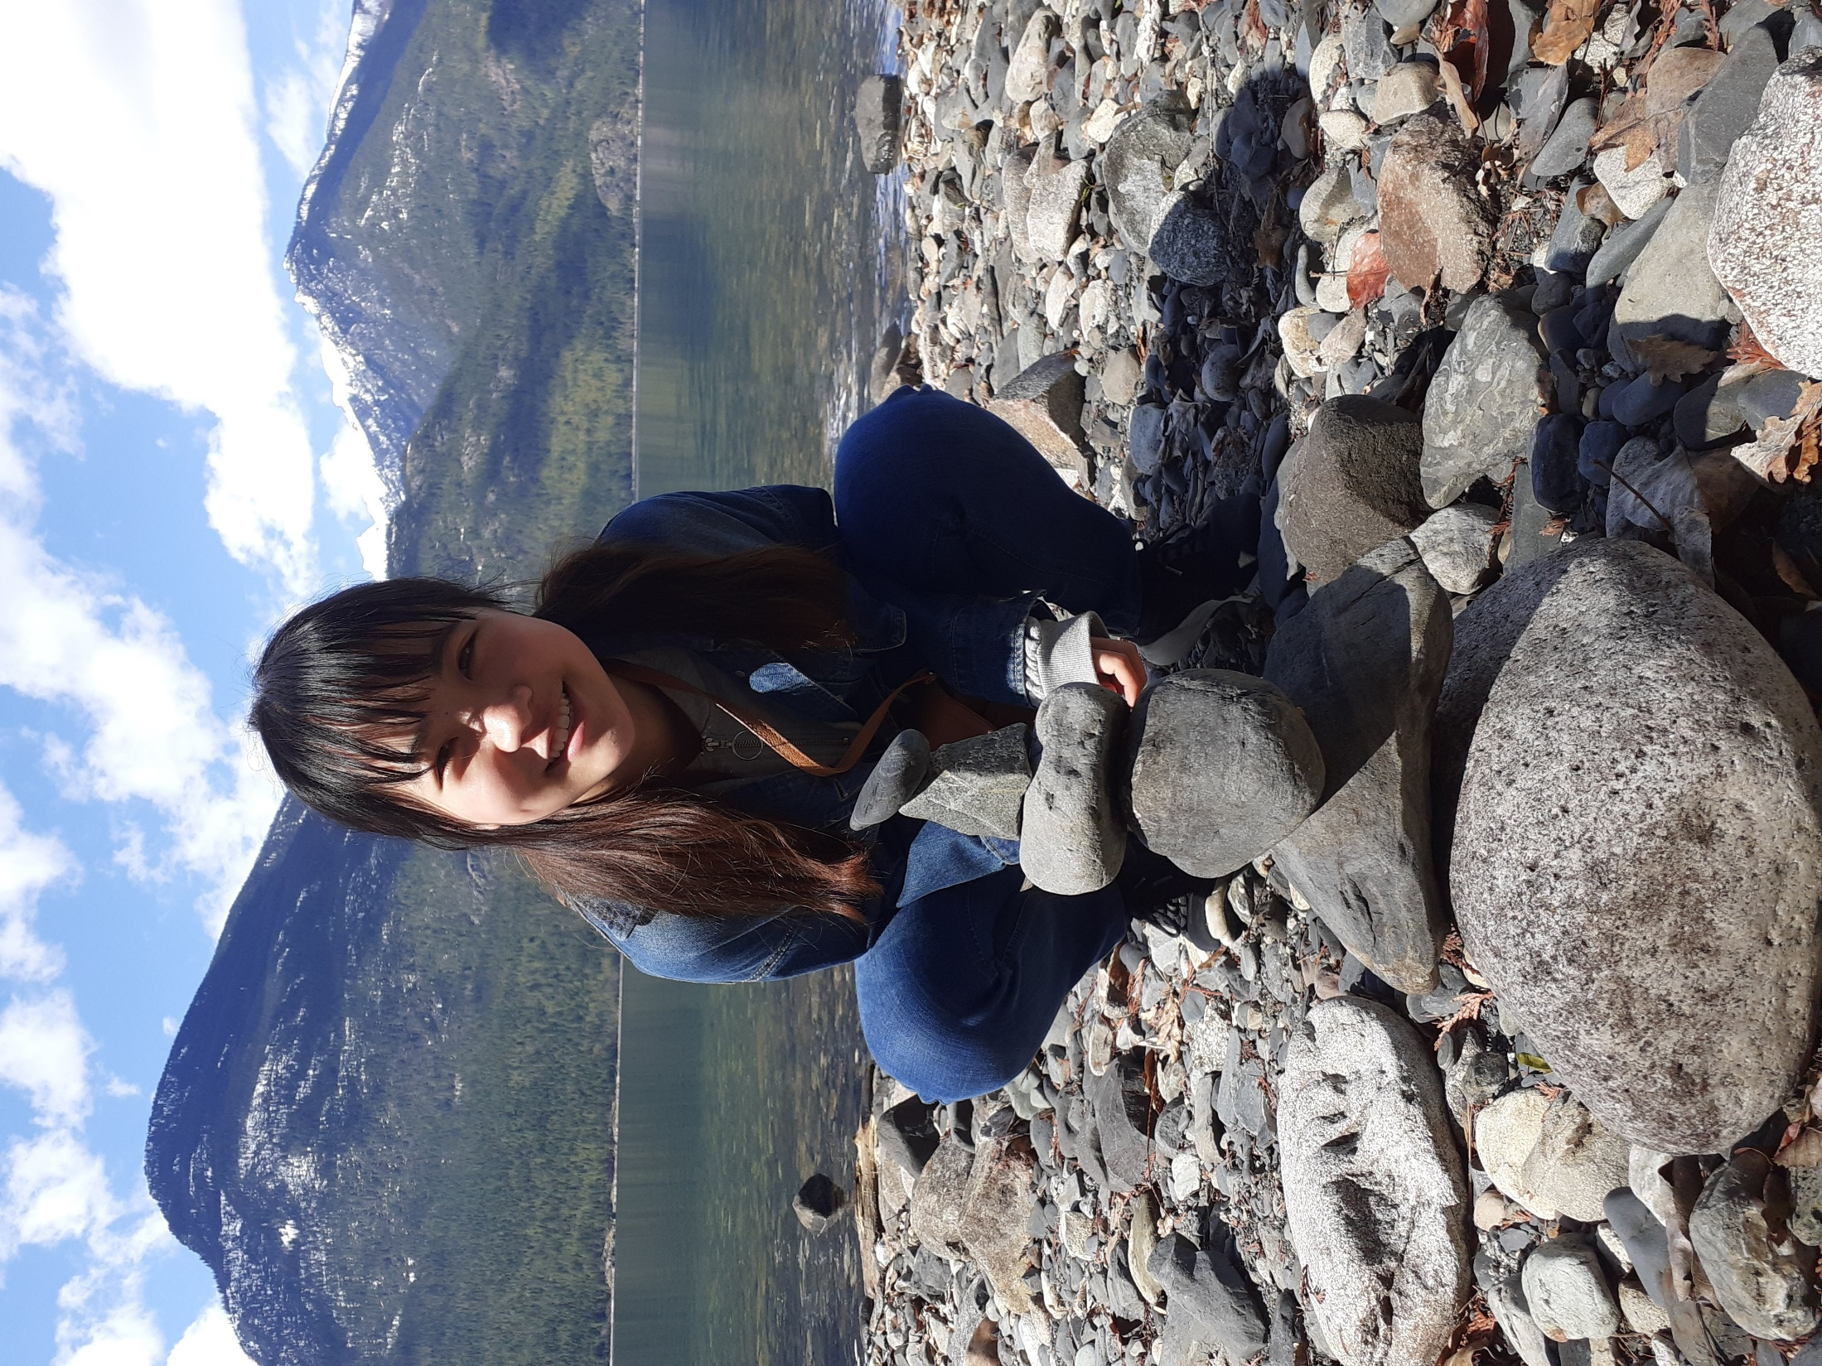
- Students paired with student mentor.

Homestay Orientation
- Attendance required.
- Online format.

Homestay Contractor Monthly Meeting
- Attendance required.
- In person at school.
- Contractor sets and communicates meeting details to students.
- Discuss homestay, academic and social concerns.

HOMESTAY
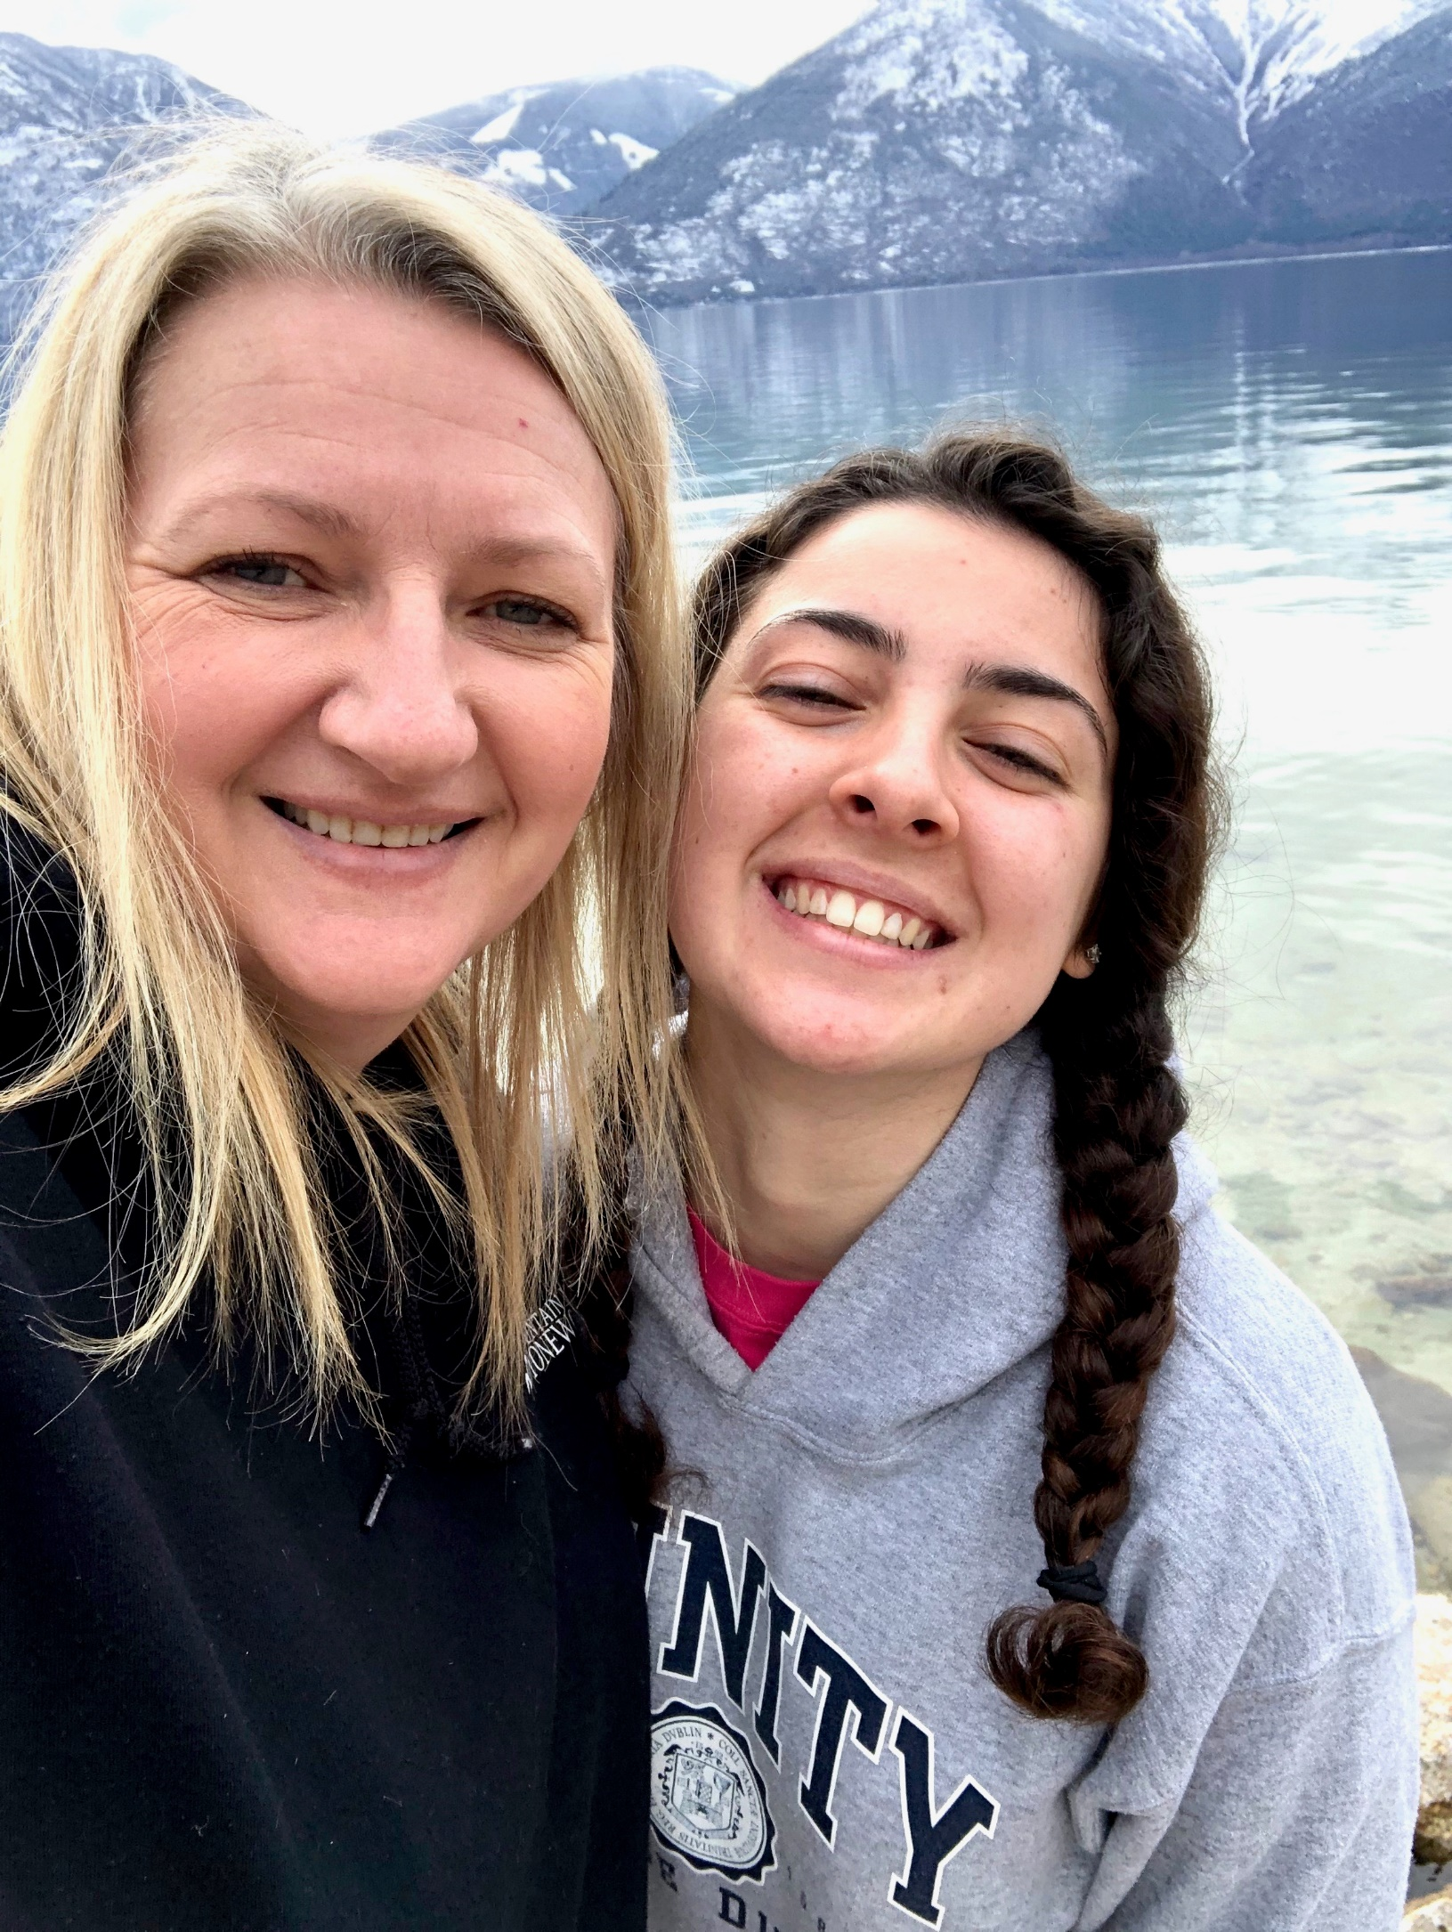
Homestay Tour
- Tour of homestay home, inside and out.
- Most tap water in Canada is safe.
- Remove shoes at the door.
- Learn recycling vs. garbage.
- Thermostat/temperature use.
- Kitchen appliance use.
- Wi-Fi use.

Family Procedures
- Discuss expectations, rules, schedules.
- Topics: computer use, shower times.
- Exchange contact info and photos with family.

Food
- Eat with homestay regularly.
- Receive varied, nutritional meals and snacks daily.
- Discuss favorite foods, join grocery shopping.
- Talk about missing home country foods.
- Learn about meal preparations, make your own breakfast/lunch.
- Responsible for own snack costs at school.
- Discuss kitchen rules and appliance use.
- Meal provided if homestay absent for dinner.

Bedroom
- Keep bedroom tidy.
- No food/drinks in bedroom without permission.
- Respect privacy; knock before entering.

Bathroom
- Ask if you are unsure how to use bathroom facilities.
- Keep the bathroom clean.
- Provide your own toiletries.
- Keep shower/bath to 15 minutes or less

Laundry
- Follow laundry schedule.
- Learn to use washer and dryer.
- Hosts provide laundry products.
- Computer Access and WIFI

Chores
- Clean up after using kitchen/bathroom.

Internet
- Use your own computer.
- Homestay provides internet (no charge).
- Internet off by 11pm.
- Misuse may lead to suspended privileges.

Cell Phones
- Working cell phone required for safety.
- No going out without a phone.
- Require Canadian phone number.
- Students pay for phone expenses.
- Options: pay-as-you-go or monthly plan.
- No long-term contracts through homestays.
- iPads/apps not sole communication method with homestay.

Curfew
- Sun-Thurs: 8pm (<16yrs), 9pm (≥16yrs).
- Fri-Sat: 11pm for all.
- Regular curfews during holidays/Pro-D days; may extend sometimes.
- Allowed out past curfew with homestay or for school activities.

Sleepovers
- Need permission from homestay and other student’s parents.
- Suitable notice required.
- Homestay parents and other student’s parents communicate with each other about arrangements.

Damage
- Kootenay Lake School District is not responsible for damage caused by the student.
- Students pay for willful damage, not wear and tear.
- The process involves an ISP, Homestay Contractor, and insurance.
- Study Insured insurance may cover costs where applicable.

LIFESTYLE
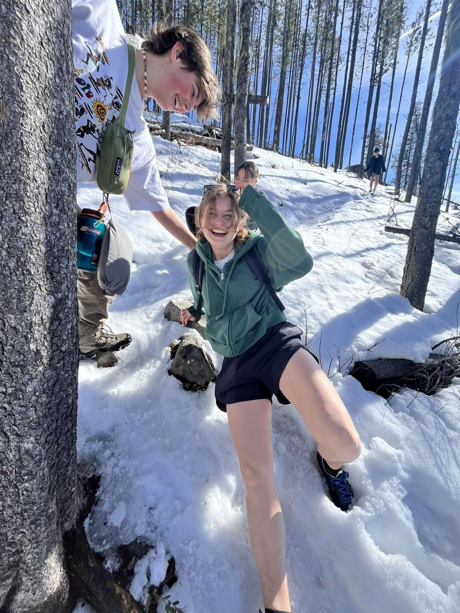
Banking
- Homestay helps open a bank account with necessary documents.
- Option to use pre-loaded Visa cards instead.
- Advised against carrying too much cash; use cards.

Job
- Not allowed on study permit.
- May lead to dismissal from school district.

Babysitting
- For safety reasons, students should not babysit.

Pets
- Not responsible for pet care in homestay.
- Cannot have personal pets in homestay.

Dating
- Introducing my partner to homestay.
- No partners in bedrooms.

Drugs and Alcohol
- Strictly prohibited.
- Immediately sent home if found using/possessing.

Religion
- Respect each other's religious beliefs.
- Optional church attendance with homestay.

Student Moves
- Contact Homestay Contractor with any issues.
- School district may move students.

Visitors
- Housing for students only, not visiting parents.
- Overnight stays with parents require completing a form, for more than three nights away out of district.

Agents Visits
- Must get permission from the International Program to visit homestay.

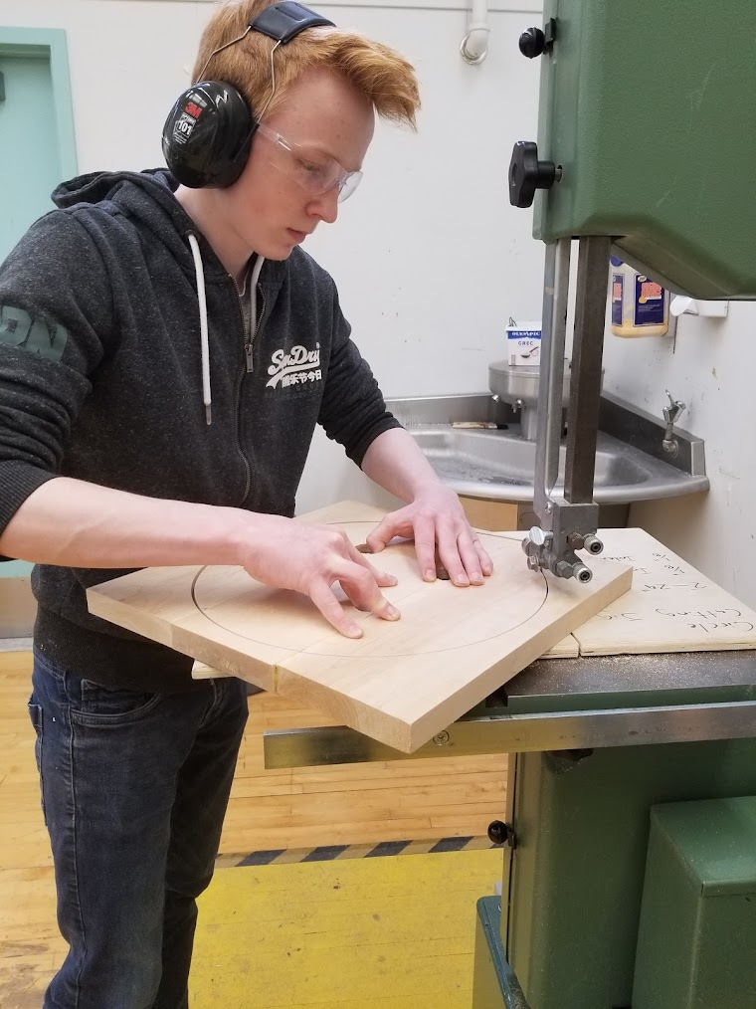
CURRICULUM

School Attendance
- Mandatory class attendance.
- Students should not miss school for any reason other than sickness.
- If sick, students talk to homestay and they report absence to school.

Learning Updates
- The school district provides learning updates (report cards) four times a year.
- Students have access to learning updates online through MyEd.

EXTRA CURRICULUM
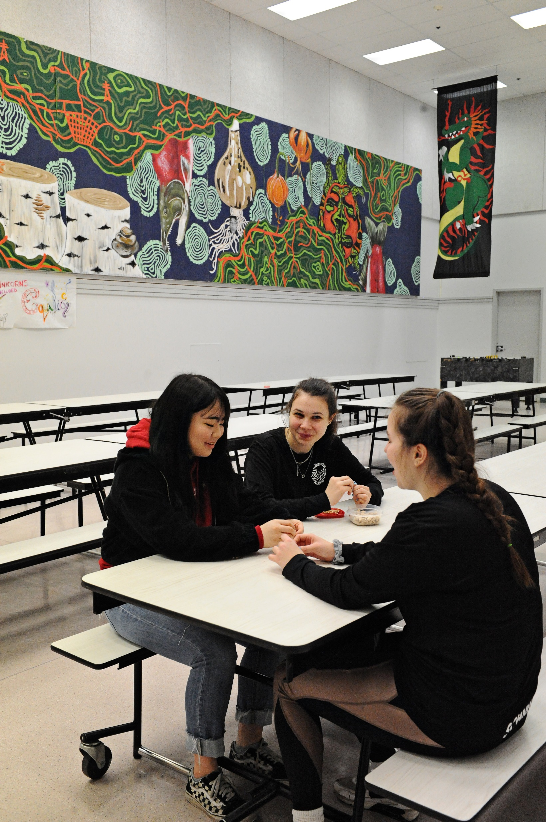
School activities
- School pays for basic school fees for core classes.
- Core classes include English, social studies, math, science, career, PE.
- Student may pay fees for athletics, arts, technology classes

Monthly Activities
- The International Program offers free monthly activities.
- Students may have to purchase lunches.
- Sign up with Contractor after discussing with homestay.

School Field Trips
- Optional teacher-organized activities.
- Need parent/guardian signature on permission forms.
- Homestays can sign for low-risk trips, natural parents for high-risk trips.
- Students pay for field trips such as skiing and hiking.

TRAVEL


Driving
- No owning, driving, borrowing, or renting vehicles.
- You may only be a passenger in cars when the driver is 25 years.
- Driver must have full license (not an ‘L’ or ‘N’ status)
- Driver can be member of their homestay family who has an ‘N’ status.
- Students may take drivers lessons with permission of natural parents.

Traveling
- Complete travel form 5 days before travel for certain conditions.
- Applies to overnight trips and day trips outside certain areas.

United States
- Complete travel form 5 days before US trip.
- Check visa/ESTA requirements in advance.
- Bring necessary documents for border crossing.

Airport
- Homestay arranges airport transport.
- Discuss flight bookings with homestay.
- Students pay for homestay transport for mid-program trips at a set mileage rate.

School Bus
- Available outside of 3 km from school.
- Homestay's responsibility to register student.

Public Transit
- Students can purchase a city bus pass at their own expense.
- Travel safely, stay in contact with homestay.
- Students must have homestay approval to use a taxi service.

Summer Storage
- $50/month storage fee if possessions in homestay over summer.
- All fees paid by the student directly to the homestay before leaving.
- Must pack and clean own space.

MEDICAL

Medical Information
- Short-term (<6 months) covered by StudyInsured.
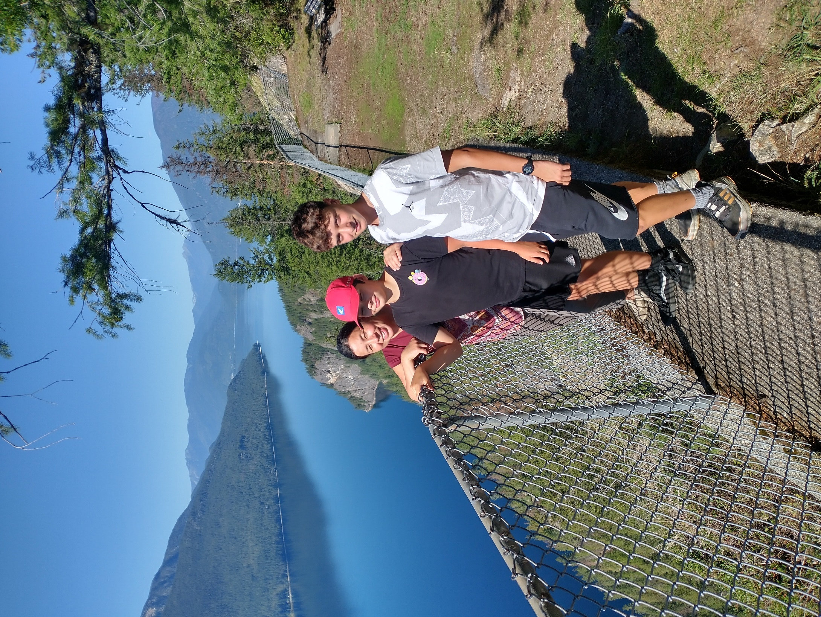
- Long-term (>6 months) initially covered by StudyInsured, then MSP after 3 months.
- Returning students stay on MSP.
- International programs apply for insurance coverage.

Maple Virtual Care
- 24/7 access to doctors via text/video.
- Preferred pricing, no claim submissions.
- Register at getmaple.ca/msh with policy number and DOB.
- Describe symptoms and chat with a doctor, diagnosis or prescription provided.

Hospital Emergency
- For medical emergencies only.
- Notify homestay and contractor immediately.
- Contractor starts claim with StudyInsured.
- Collect and share medical documents (written diagnosis, and follow up recommendations)
- In severe emergencies, call the number on your ID card

Mental Wellness
- 24/7 support through the Stay Healthy at School program.
- Access to English-speaking counselor or one speaking your home language.
- StudyInsured card provided in welcome package
- Always carry StudyInsured and MSP card (keep a picture of the Medical Card on your phone).

Coverage When Traveling Outside Canada
- Covered globally except in home country, limited to 30 days in the USA.
- No coverage in home country unless in a school/training program.
- For emergencies, call StudyInsured toll-free.

Students on MSP - Traveling Outside BC
- Covered for eligible expenses in BC.
- Carry StudyInsured card when traveling outside BC.
- For medical help outside BC, call StudyInsured Assistance.

Vaccinations
- Homestay parents cannot sign consent forms; consult Homestay Contractor.

Dental Care
- Not covered unless due to an accident.

CULTURE SHOCK

Defined
- Normal reaction to an unfamiliar environment.
- Experiences include excitement, frustration, depression, exhaustion.
- Describes adjustment to unfamiliar surroundings.

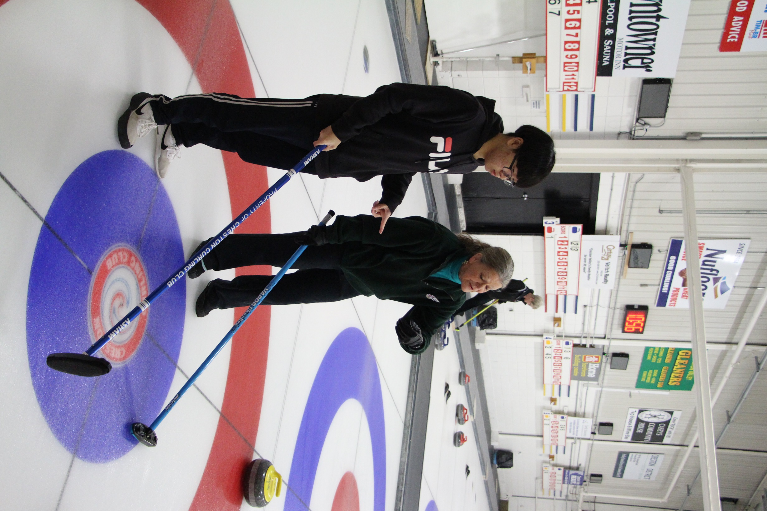
Symptoms
- Symptoms vary boredom, withdrawal, loneliness, over-sleeping, irritation, body pains, longing for home, criticizing local customs.

Stages
- Honeymoon Stage - Positive and curious.
- Irritability and Hostility - Feeling differences are inferior.
- Gradual Adjustment - More relaxed, balanced view.
- Adaptation of Biculturalism - Sense of belonging, sensitivity to host culture.
- Re-entry Shock - Home feels different than remembered.
Support
- Talk with homestay or contractor
- Connect virtually with natural parents
Use Stay Healthy School (mental health support service).

Student misconduct leads to progressive logical consequences as seen below.


Disrespect  (Start at level 1)  - Self  - Environment  - Others | Behavior  (Start at level 4 or 5)  - Bullying  - Violence  - Defiance | Banned Substances  (Start at level 5)  - Tobacco, vaping  - Illegal drugs  - Alcohol  - Explicit materials

Level 1
Student
(Prevention – orientation, handbook)

Level 2
Homestay Parent
(Intervention – contractor informed)

Level 3
Homestay Contractor
(Warning, agent & natural parent informed)

Level 4
District Principal
(Warning, agent & natural parent informed)

Level 5
School District
(Program Dismissal)

SUMMARY

Student Responsibilities
- Follow curfew.
- Respect family, belongings, and rules.
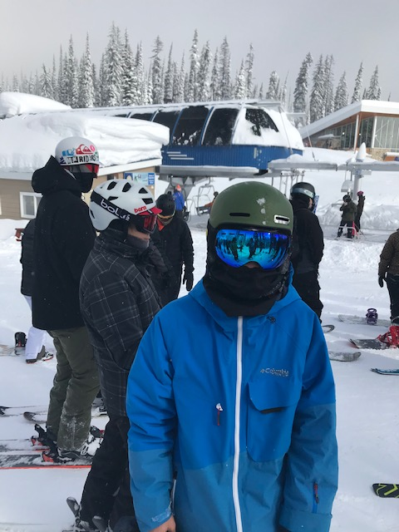
- Keep the bedroom and bathroom tidy.
- No food/drink in bedroom without permission.
- No dating partners in the bedroom.
- Eat dinner with family at least 5 nights a week.
- Clean up after using the kitchen.
- No alcohol or drugs.
- Pay for willful damage.
- Introduce friends and get permission for guests.
- Inform homestay of whereabouts and plans.
- Respond to all calls and texts.
- Use Travel Permission form for overnight stays.
- Discuss flight plans with homestay for airport transportation.

Homestay Parent Responsibilities
- Provide contact information.
- Provide a clean environment.
- Provide weekly clean bed linens and towels.
- Three meals a day plus snacks, including family meals five times a week.
- Reasonable use of home and utilities with instruction.
- Set reasonable, age-appropriate rules.
- Ensure students are offline by 11pm on school nights.
- Provide a house key/code.
- Offer homework and assignment assistance.
- Responsible for school transportation.
- Contact the school about student absences.
- Not responsible for free airport transportation during breaks.
- Ensure the student’s phone has sufficient power.
- Maintain curfew and report violations.
- Assist with medical needs and doctor/hospital visits.
- Inform Homestay Contractor of home changes.
- No hosting of Private and District students simultaneously.
- Ensure adherence to District Rules and contact Contractor if issues arise.

